

HOUSE PRICE PREDICITION

Submitted by:

ARUMOY SAHA

**ACKNOWLEDGMENT**

Following are the references used in this House price prediction project:

* <https://www.cse.ust.hk/~rossiter/independent_studies_projects/real_estate_prediction/real_estate_report.pdf>
* <https://towardsdatascience.com/create-a-model-to-predict-house-prices-using-python-d34fe8fad88f>
* <https://yalantis.com/blog/predictive-algorithm-for-house-price/>

**INTRODUCTION**

* Business Problem Framing:

We are required to model the price of houses with the available independent variables. This model will then be used by the management to understand how exactly the prices vary with the variables. They can accordingly manipulate the strategy of the firm and concentrate on areas that will yield high returns. Further, the model will be a good way for the management to understand the pricing dynamics of a new market.

* Conceptual Background of the Domain Problem:

A US-based housing company named Surprise Housing has comes up with a decision to enter the Australian market in the Real Estate Industry. The company uses data analytics to purchase houses at a price below their actual values and flip them at a higher price. For the same purpose, the company has collected a data set from the sale of houses in Australia. The data is provided in the CSV file.

The company is looking at prospective properties to buy houses to enter the market. I need to build a model using Machine Learning in order to predict the actual value of the prospective properties and decide whether to invest in them or not.

* Review of Literature:

Houses are one of the necessary need of each and every person around the globe and therefore housing and real estate market is one of the markets which is one of the major contributors in the world’s economy. It is a very large market and there are various companies working in the domain. Data science comes as a very important tool to solve problems in the domain to help the companies increase their overall revenue, profits, improving their marketing strategies and focusing on changing trends in house sales and purchases. Predictive modelling, Market mix modelling, recommendation systems are some of the machine learning techniques used for achieving the business goals for housing companies. Our problem is related to one such housing company. As per the requirement the company is looking at prospective properties to buy houses to enter the market. I need to build a model using Machine Learning in order to predict the actual value of the prospective properties and decide whether to invest in them or not. For this company wants to know:

* Which variables are important to predict the price of variable?
* How do these variables describe the price of the house?
* Motivation for the Problem Undertaken:

This project helps me understand the House price prediction for a foreign country (Australia) and the real estate industry and its customer behaviour. With the right set of datasets in hand I have built a model that helps the enterprise take the right decision that is whether to enter into the market and invest in housing property or nor and the selling price of the property. This also motivate learn about real estate industry in details and how it helps build the economic development in the particular country.

**Analytical Problem Framing**

* Mathematical/ Analytical Modelling of the Problem:

In this particular project I need to understand whether to invest in the Australian market and in real estate industry and what are the important factors to predict the price of the house. I have used a Gradient Boosting Regressor model to predict the housing pricing and could help the client in further investment in this particular Australians market and into property segment and improvement in choice of consumers.

* Data Sources and their formats:
* Data sources are provided internally by the enterprise.

MSSubClass: Identifies the type of dwelling involved in the sale.

20 1-STORY 1946 & NEWER ALL STYLES

30 1-STORY 1945 & OLDER

40 1-STORY W/FINISHED ATTIC ALL AGES

45 1-1/2 STORY - UNFINISHED ALL AGES

50 1-1/2 STORY FINISHED ALL AGES

60 2-STORY 1946 & NEWER

70 2-STORY 1945 & OLDER

75 2-1/2 STORY ALL AGES

80 SPLIT OR MULTI-LEVEL

85 SPLIT FOYER

90 DUPLEX - ALL STYLES AND AGES

120 1-STORY PUD (Planned Unit Development) - 1946 & NEWER

150 1-1/2 STORY PUD - ALL AGES

160 2-STORY PUD - 1946 & NEWER

180 PUD - MULTILEVEL - INCL SPLIT LEV/FOYER

190 2 FAMILY CONVERSION - ALL STYLES AND AGES

MSZoning: Identifies the general zoning classification of the sale.

A Agriculture

C Commercial

FV Floating Village Residential

I Industrial

RH Residential High Density

RL Residential Low Density

RP Residential Low Density Park

RM Residential Medium Density

LotFrontage: Linear feet of street connected to property

LotArea: Lot size in square feet

Street: Type of road access to property

Grvl Gravel

Pave Paved

Alley: Type of alley access to property

Grvl Gravel

Pave Paved

NA No alley access

LotShape: General shape of property

Reg Regular

IR1 Slightly irregular

IR2 Moderately Irregular

IR3 Irregular

LandContour: Flatness of the property

Lvl Near Flat/Level

Bnk Banked - Quick and significant rise from street grade to building

HLS Hillside - Significant slope from side to side

Low Depression

Utilities: Type of utilities available

AllPub All public Utilities (E,G,W,& S)

NoSewr Electricity, Gas, and Water (Septic Tank)

NoSeWa Electricity and Gas Only

ELO Electricity only

LotConfig: Lot configuration

Inside Inside lot

Corner Corner lot

CulDSac Cul-de-sac

FR2 Frontage on 2 sides of property

FR3 Frontage on 3 sides of property

LandSlope: Slope of property

Gtl Gentle slope

Mod Moderate Slope

Sev Severe Slope

Neighborhood: Physical locations within Ames city limits

Blmngtn Bloomington Heights

Blueste Bluestem

BrDale Briardale

BrkSide Brookside

ClearCr Clear Creek

CollgCr College Creek

Crawfor Crawford

Edwards Edwards

Gilbert Gilbert

IDOTRR Iowa DOT and Rail Road

MeadowV Meadow Village

Mitchel Mitchell

Names North Ames

NoRidge Northridge

NPkVill Northpark Villa

NridgHt Northridge Heights

NWAmes Northwest Ames

OldTown Old Town

SWISU South & West of Iowa State University

Sawyer Sawyer

SawyerW Sawyer West

Somerst Somerset

StoneBr Stone Brook

Timber Timberland

Veenker Veenker

Condition1: Proximity to various conditions

Artery Adjacent to arterial street

Feedr Adjacent to feeder street

Norm Normal

RRNn Within 200' of North-South Railroad

RRAn Adjacent to North-South Railroad

PosN Near positive off-site feature--park, greenbelt, etc.

PosA Adjacent to postive off-site feature

RRNe Within 200' of East-West Railroad

RRAe Adjacent to East-West Railroad

Condition2: Proximity to various conditions (if more than one is present)

Artery Adjacent to arterial street

Feedr Adjacent to feeder street

Norm Normal

RRNn Within 200' of North-South Railroad

RRAn Adjacent to North-South Railroad

PosN Near positive off-site feature--park, greenbelt, etc.

PosA Adjacent to postive off-site feature

RRNe Within 200' of East-West Railroad

RRAe Adjacent to East-West Railroad

BldgType: Type of dwelling

1Fam Single-family Detached

2FmCon Two-family Conversion; originally built as one-family dwelling

Duplx Duplex

TwnhsE Townhouse End Unit

TwnhsI Townhouse Inside Unit

HouseStyle: Style of dwelling

1Story One story

1.5Fin One and one-half story: 2nd level finished

1.5Unf One and one-half story: 2nd level unfinished

2Story Two story

2.5Fin Two and one-half story: 2nd level finished

2.5Unf Two and one-half story: 2nd level unfinished

SFoyer Split Foyer

SLvl Split Level

OverallQual: Rates the overall material and finish of the house

10 Very Excellent

9 Excellent

8 Very Good

7 Good

6 Above Average

5 Average

4 Below Average

3 Fair

2 Poor

1 Very Poor

OverallCond: Rates the overall condition of the house

10 Very Excellent

9 Excellent

8 Very Good

7 Good

6 Above Average

5 Average

4 Below Average

3 Fair

2 Poor

1 Very Poor

YearBuilt: Original construction date

YearRemodAdd: Remodel date (same as construction date if no remodeling or additions)

RoofStyle: Type of roof

Flat Flat

Gable Gable

Gambrel Gabrel (Barn)

Hip Hip

Mansard Mansard

Shed Shed

RoofMatl: Roof material

ClyTile Clay or Tile

CompShg Standard (Composite) Shingle

Membran Membrane

Metal Metal

Roll Roll

Tar&Grv Gravel & Tar

WdShake Wood Shakes

WdShngl Wood Shingles

Exterior1st: Exterior covering on house

AsbShng Asbestos Shingles

AsphShn Asphalt Shingles

BrkComm Brick Common

BrkFace Brick Face

CBlock Cinder Block

CemntBd Cement Board

HdBoard Hard Board

ImStucc Imitation Stucco

MetalSd Metal Siding

Other Other

Plywood Plywood

PreCast PreCast

Stone Stone

Stucco Stucco

VinylSd Vinyl Siding

Wd Sdng Wood Siding

WdShing Wood Shingles

Exterior2nd: Exterior covering on house (if more than one material)

AsbShng Asbestos Shingles

AsphShn Asphalt Shingles

BrkComm Brick Common

BrkFace Brick Face

CBlock Cinder Block

CemntBd Cement Board

HdBoard Hard Board

ImStucc Imitation Stucco

MetalSd Metal Siding

Other Other

Plywood Plywood

PreCast PreCast

Stone Stone

Stucco Stucco

VinylSd Vinyl Siding

Wd Sdng Wood Siding

WdShing Wood Shingles

MasVnrType: Masonry veneer type

BrkCmn Brick Common

BrkFace Brick Face

CBlock Cinder Block

None None

Stone Stone

MasVnrArea: Masonry veneer area in square feet

ExterQual: Evaluates the quality of the material on the exterior

Ex Excellent

Gd Good

TA Average/Typical

Fa Fair

Po Poor

ExterCond: Evaluates the present condition of the material on the exterior

Ex Excellent

Gd Good

TA Average/Typical

Fa Fair

Po Poor

Foundation: Type of foundation

BrkTil Brick & Tile

CBlock Cinder Block

PConc Poured Contrete

Slab Slab

Stone Stone

Wood Wood

BsmtQual: Evaluates the height of the basement

Ex Excellent (100+ inches)

Gd Good (90-99 inches)

TA Typical (80-89 inches)

Fa Fair (70-79 inches)

Po Poor (<70 inches

NA No Basement

BsmtCond: Evaluates the general condition of the basement

Ex Excellent

Gd Good

TA Typical - slight dampness allowed

Fa Fair - dampness or some cracking or settling

Po Poor - Severe cracking, settling, or wetness

NA No Basement

BsmtExposure: Refers to walkout or garden level walls

Gd Good Exposure

Av Average Exposure (split levels or foyers typically score average or above)

Mn Mimimum Exposure

No No Exposure

NA No Basement

BsmtFinType1: Rating of basement finished area

GLQ Good Living Quarters

ALQ Average Living Quarters

BLQ Below Average Living Quarters

Rec Average Rec Room

LwQ Low Quality

Unf Unfinshed

NA No Basement

BsmtFinSF1: Type 1 finished square feet

BsmtFinType2: Rating of basement finished area (if multiple types)

GLQ Good Living Quarters

ALQ Average Living Quarters

BLQ Below Average Living Quarters

Rec Average Rec Room

LwQ Low Quality

Unf Unfinshed

NA No Basement

BsmtFinSF2: Type 2 finished square feet

BsmtUnfSF: Unfinished square feet of basement area

TotalBsmtSF: Total square feet of basement area

Heating: Type of heating

Floor Floor Furnace

GasA Gas forced warm air furnace

GasW Gas hot water or steam heat

Grav Gravity furnace

OthW Hot water or steam heat other than gas

Wall Wall furnace

HeatingQC: Heating quality and condition

Ex Excellent

Gd Good

TA Average/Typical

Fa Fair

Po Poor

CentralAir: Central air conditioning

N No

Y Yes

Electrical: Electrical system

SBrkr Standard Circuit Breakers & Romex

FuseA Fuse Box over 60 AMP and all Romex wiring (Average)

FuseF 60 AMP Fuse Box and mostly Romex wiring (Fair)

FuseP 60 AMP Fuse Box and mostly knob & tube wiring (poor)

Mix Mixed

1stFlrSF: First Floor square feet

2ndFlrSF: Second floor square feet

LowQualFinSF: Low quality finished square feet (all floors)

GrLivArea: Above grade (ground) living area square feet

BsmtFullBath: Basement full bathrooms

BsmtHalfBath: Basement half bathrooms

FullBath: Full bathrooms above grade

HalfBath: Half baths above grade

Bedroom: Bedrooms above grade (does NOT include basement bedrooms)

Kitchen: Kitchens above grade

KitchenQual: Kitchen quality

Ex Excellent

Gd Good

TA Typical/Average

Fa Fair

Po Poor

TotRmsAbvGrd: Total rooms above grade (does not include bathrooms)

Functional: Home functionality (Assume typical unless deductions are warranted)

Typ Typical Functionality

Min1 Minor Deductions 1

Min2 Minor Deductions 2

Mod Moderate Deductions

Maj1 Major Deductions 1

Maj2 Major Deductions 2

Sev Severely Damaged

Sal Salvage only

Fireplaces: Number of fireplaces

FireplaceQu: Fireplace quality

Ex Excellent - Exceptional Masonry Fireplace

Gd Good - Masonry Fireplace in main level

TA Average - Prefabricated Fireplace in main living area or Masonry Fireplace in basement

Fa Fair - Prefabricated Fireplace in basement

Po Poor - Ben Franklin Stove

NA No Fireplace

GarageType: Garage location

2Types More than one type of garage

Attchd Attached to home

Basement Basement Garage

BuiltIn Built-In (Garage part of house - typically has room above garage)

CarPort Car Port

Detchd Detached from home

NA No Garage

GarageYrBlt: Year garage was built

GarageFinish: Interior finish of the garage

Fin Finished

RFn Rough Finished

Unf Unfinished

NA No Garage

GarageCars: Size of garage in car capacity

GarageArea: Size of garage in square feet

GarageQual: Garage quality

Ex Excellent

Gd Good

TA Typical/Average

Fa Fair

Po Poor

NA No Garage

GarageCond: Garage condition

Ex Excellent

Gd Good

TA Typical/Average

Fa Fair

Po Poor

NA No Garage

PavedDrive: Paved driveway

Y Paved

P Partial Pavement

N Dirt/Gravel

WoodDeckSF: Wood deck area in square feet

OpenPorchSF: Open porch area in square feet

EnclosedPorch: Enclosed porch area in square feet

3SsnPorch: Three season porch area in square feet

ScreenPorch: Screen porch area in square feet

PoolArea: Pool area in square feet

PoolQC: Pool quality

Ex Excellent

Gd Good

TA Average/Typical

Fa Fair

NA No Pool

Fence: Fence quality

GdPrv Good Privacy

MnPrv Minimum Privacy

GdWo Good Wood

MnWw Minimum Wood/Wire

NA No Fence

MiscFeature: Miscellaneous feature not covered in other categories

Elev Elevator

Gar2 2nd Garage (if not described in garage section)

Othr Other

Shed Shed (over 100 SF)

TenC Tennis Court

NA None

MiscVal: $Value of miscellaneous feature

MoSold: Month Sold (MM)

YrSold: Year Sold (YYYY)

SaleType: Type of sale

WD Warranty Deed - Conventional

CWD Warranty Deed - Cash

VWD Warranty Deed - VA Loan

New Home just constructed and sold

COD Court Officer Deed/Estate

Con Contract 15% Down payment regular terms

ConLw Contract Low Down payment and low interest

ConLI Contract Low Interest

ConLD Contract Low Down

Oth Other

SaleCondition: Condition of sale

Normal Normal Sale

Abnorml Abnormal Sale - trade, foreclosure, short sale

AdjLand Adjoining Land Purchase

Alloca Allocation - two linked properties with separate deeds, typically condo with a garage unit

Family Sale between family members

Partial Home was not completed when last assessed (associated with New Homes)

* Data Pre-processing:

In the data pre-processing stage, I have found out if there is any missing data in dataset, for a particular column if there are any outliers present and how to handle the outliers. I have also dropped a few columns that are not require for model building process. I have also found the total shape of the data set. I have also found out the dataset description using describe method. So, in this pre-processing process I have mainly cleansed the data and prepared the right set of data for further processing & for predicting the model.

* Data Inputs- Logic- Output Relationships:

To find out the relationship between all the input variable I have used correlation function and find out whether there is a positive/negative relationship between a pair of variables. From this describe function that also known as Five-point summary analysis if there are any outliers are present for a particular column. Also five point summary analysis was done for the target variable to explore & understand the data in a better way.

* State the set of assumptions (if any) related to the problem under consideration:

Since all the dataset provided and defined properly so in this dataset, I assume Sale Price/LogofPrice as the target variable for this project. Rest of the parameters are used as input variables.

* Hardware and Software Requirements and Tools Used:

For this particular dataset the Hardware is used Windows as operating system, and the software used are mainly Jupyter notebook for model building and various internal packages that are defined in the anaconda/jupyter notebook.

**Model/s Development and Evaluation**

* Identification of possible problem-solving approaches (methods):

For this particular project I have used different Regression models to predict the outcome of this dataset. After the model implementation GradientBoostinRegressor method predicted the best outcome out of all the process in terms of accuracy score and also I have used cross validation to flag the problem related overfitting or selection bias for the dataset and hence we can use this model for further evaluation.

* Testing of Identified Approaches (Algorithms):

I have used mainly different Regression methods to get the outcome of the house price prediction and 75% data used for training purpose and rest 25% are used for testing the prediction of the accuracy score for this machine learning model building process.

* Run and Evaluate selected models:

To predict the result of this dataset below are machine learning models used for evaluations.

|  |  |
| --- | --- |
| **ML Algorithm Used** | **Predicted Score** |
| Random Forest Regressor | 87.54% |
| Decision Tree Regressor | 77.86% |
| Gradient Boosting Regressor | 90.18% |
| Ada Boosting Regressor | 83.43% |
| Extra Tree Regressor | 87.50% |
| Linear Regression | 88.39% |

**Out of all the machine learning models used I have selected Gradient Boosting Regressor model for further evaluation of this project.**

* Key Metrics for success in solving problem under consideration

The key metrics that were mainly taken into consideration were the followings:

* Saleprice
* Neighborhood
* MSSubClass
* MSZoning
* SaleType
* Condition1
* Condition2
* SaleCondition

These are the prime metrics under consideration, but there are factors too can be considered for solving the house price prediction.

* Visualizations

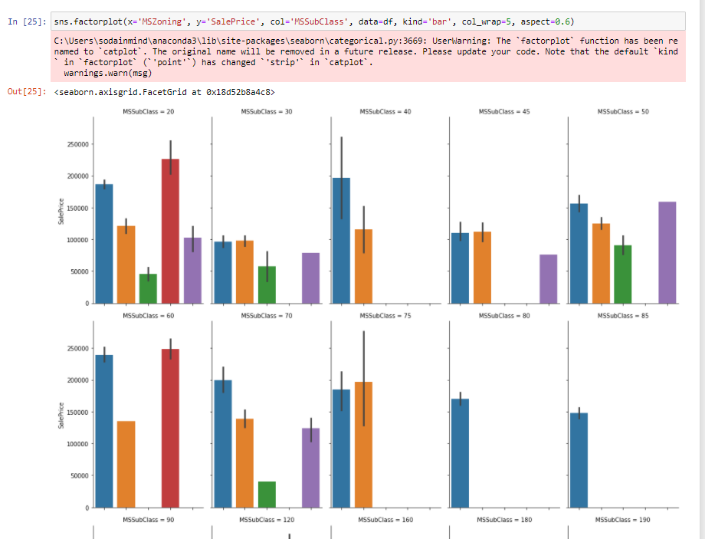

From the above factorplot I have understand the general zoning classification of the sale and sale price for the particular zone and also find out the type of dwelling involved in the sale of the house.

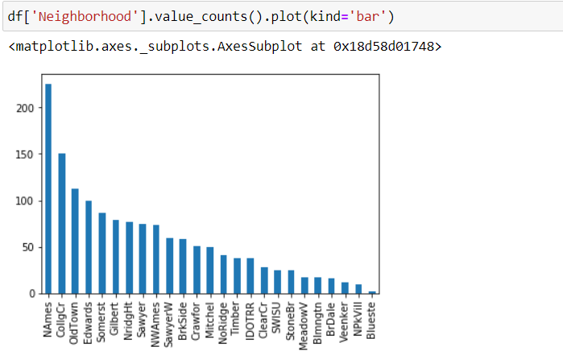

From the above bar plot I have understand the Physical locations within city limits.

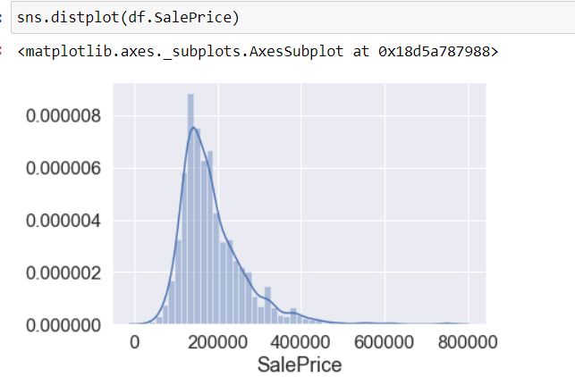

From the above distribution plot I got to know how the house sales price are distributed using the univariate analysis.

* Interpretation of the Results
* Gradient Boosting Regressor algorithm predict best result for this dataset.
* I have also find out the RMSE score that is 0.015 for the predicted value of gradient boosting regressor algorithm technique.
* I have also find out the Ridge (reduce the model complexity by keeping all the parameters) & Lasso (minimize the error also find out the shrinkage) method using cross validation technique to optimized the model for prediction and regularize (**some bias over high variance**) it.

**CONCLUSION**

* Key Findings and Conclusions of the Study:
* I used various regressor methods and out of all machine learning algorithm used, Gradient boosting Regressor yields the best results.
* This house price prediction can be used market development as well as for economic development of the country.
* Learning Outcomes of the Study in respect of Data Science:

As per as learning outcomes is concerned, I have learnt the following things:

* Algorithm need to be used by understanding the dataset.
* From describe method we can get some knowledge related to outliers present in the particular columns (large difference between 75th percentile and maximum percentile)
* I also understand the visualization of related features and importance related to dataset.

Challenges:

* It was difficult to load the dataset in notebook as it took some time.
* Running each line code was a bit slow in notebook, possibly due to high volume of data.
* Since the sale price is depends on too many factors so understanding dynamic pricing was a bit challenging but further research can be done on this to understand it in a better way.
* Limitations of this work and Scope for Future Work:
* Since I have only used a sample dataset, hence sometimes it is difficult to understand the overall impact of this house price prediction process.
* I have not used the Elastic Net regressor method for predicting the outcome, otherwise I would have find out the ridge regression coefficient and then done step by step lasso sort shrinkage coefficient then the predicted outcome may have been be better.